Paris, 9. June

PENTAX O-GPS2
A handy GPS unit for digital SLR cameras,
offering innovative features for effortless tracking and photographing of celestial bodies
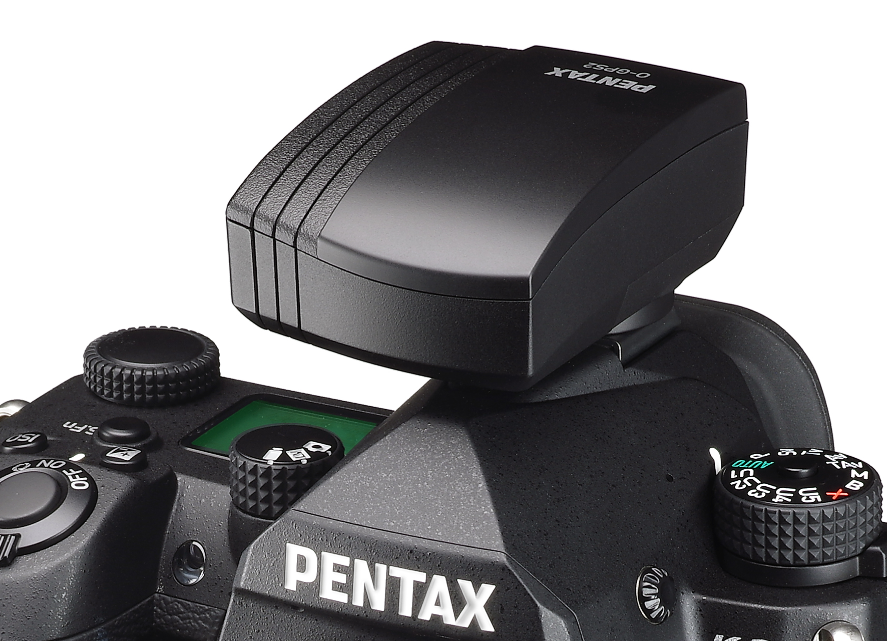

RICOH IMAGING COMPANY, LTD. announced the launch of the PENTAX O-GPS2. Designed for use with PENTAX digital SLR cameras, this versatile GPS unit not only gives basic location data, but also offers an array of original features that allow for the effortless tracking and photographing of celestial bodies.

The PENTAX O-GPS2 will be available from June,
The suggested retail price will be € 249,99 / £ 249,99 / 279 CHF

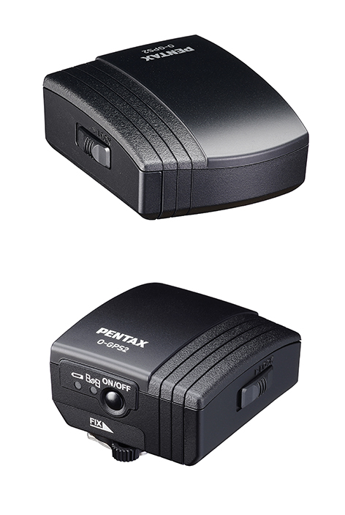
The PENTAX O-GPS2 has been developed as a successor to the "O-GPS1" (released in June 2011). In addition to GPS in the US, QZSS in Japan, GLONASS and Galileo can be newly received. Simply by mounting the PENTAX O-GPS2 onto the hotshoe of a PENTAX digital SLR camera,* the user can record the latitude, longitude, altitude, universal time coordinated (UTC) and aspect of shooting locations onto captured images. Image files carrying the location data, can be used to track shooting locations and review location data on a PC. The location data stored on such files also makes it much easier to sort and file recorded images.

By coupling the location data with the camera’s SR (Shake Reduction) system, the unit offers a range of unique, advanced applications, including ASTROTRACER, Simple Navigation and Electronic Compass.

* Compatible models are the PENTAX K-3 Mark III, KP, K-3, K-5II, K-5IIs, K-5, K-S2, K-S1,
K-70, K-50, K-30, K-r, K-01, 645Z, 645D (as of May 2022). All applications will not support all models.

Major Features

1. GPS function for effortless recording of shooting location data
The O-GPS2 mounts on the hotshoe of a compatible camera and records the latitude, longitude, altitude, universal time coordinated (UTC) and direction of the shooting location onto captured images. In addition to GPS in the US and QZSS in Japan, GLONASS and Galileo can be newly received.

2. ASTROTRACER for effortless astronomical photography
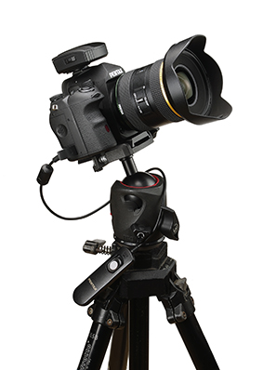
When mounted on the corresponding PENTAX digital SLR cameras body, the O-GPS2 also offers the advanced ASTROTRACER function,** which couples the unit with the camera’s SR (Shake Reduction) system for the effortless tracing and photographing of celestial bodies. The unit calculates the movement of stars, planets, and other bodies using the latitude obtained from the location data and the camera’s alignment data (horizontal and vertical inclinations and aspect) obtained from its magnetic and acceleration sensors, then shifts the camera’s image sensor in synchronization with the movement of the objects.*** As the result, stars and other bodies are captured as solid points rather than blurry streaks, even during extended exposures.
It also makes astronomical photography much simpler, as it requires only a tripod and eliminates the need for an additional accessory such as an equatorial telescope.
In addition to the normal Type 1, the Type 2 that can be used in combination with the PENTAX K-3 Mark III makes the image sensor follow the movement of the celestial body at half the speed of the Type 1. You can suppress the flow of the landscape on the ground and shoot both the stars and the landscape in a well-balanced manner.

** This function is available only when the O-GPS2 is mounted on a PENTAX digital SLR cameras body equipped with a SR system.

*** The duration of ASTROTRACER operation may vary depending on photographic conditions.

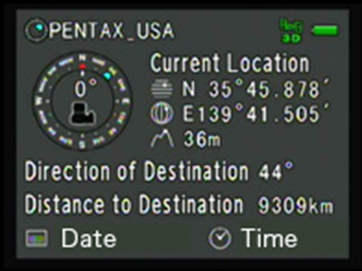
3. Simple Navigation to indicate location data to a destination
The O-GPS2 offers a Simple Navigation function, which calculates the direction and distance to a given destination from the current position. The user can either locate destinations using location data stored on recorded images, or register and/or assign them by uploading location data created on a PC.

4. Electronic Compass function to indicate and record direction
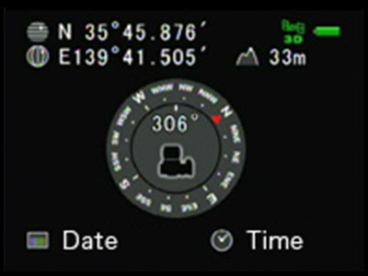
The O-GPS2 comes equipped with an Electronic Compass function, which displays the camera’s direction on its LCD monitor with great precision. Using the aspect of geomagnetism detected by its magnetic sensor and the location data, the unit indicates the aspect in relation to true north. The user can also record directional data on captured images.

5. Other features
- Simplified weather-resistant construction for use in light rain
- Independent power source (one AAA-size battery) to eliminate the need for power
supply from the camera body

Major Specifications
Product Name | PENTAX GPS UNIT O-GPS2
Type | Clip-on GPS unit
Compatible Cameras | 645Z, 645D, K-3 Mark III, KP, K-3, K-5II, K-5IIs, K-5, K-S2, K-S1, K-70, K-50, K-30, K-r,  K-01
Recorded Information | Latitude, Longitude, Altitude, Time (UTC), Direction
Receiving Function | GPS, SBAS, QZSS, GLONASS, Galileo
Acquisition Time | Cold-start: approx. 40 seconds  Hot-start: approx. 5 seconds
Positioning Interval | 1.5 second
GPS Accuracy | 10ｍ RMS
Geodesics | World Geodetic System (WGS84)
Electronic Compass | Accuracy: ±5° (precise calibration)  Positioning Interval: approx. 8 times  Reference Direction: True North
Dimensions | Approx. 49.0mm (W) x 33.0mm (H) x 59.5mm (D)
Weight | Approx. 63g (including alkaline battery), approx. 52g (unit only)
Power Source | AAA battery x 1 (alkaline battery, nickel-metal hydride battery, or lithium battery)
Operating Time | approx. 5 hours (23℃) / 3 hours (0℃) with alkaline battery  approx. 5 hours (23℃) / 5 hours (0℃) with nickel-metal hydride battery  approx. 9 hours (23℃) / 9 hours (0℃) with lithium battery  The operating time is a guide based on our measurement conditions. It may vary depending on usage conditions.
Individual Package | 183 x 40 x 120 mm (W x H x D)
SKU / EAN | 30364 / '0027075304703

About RICOH IMAGING COMPANY Ltd.

RICOH COMPANY Ltd. has been a leading provider of document management solutions, IT services, commercial and industrial printing, digital cameras and industrial systems for more than 80 years, supporting digital workplaces with innovative technologies and services that enable people to work smarter.
The Ricoh Group is headquartered in Tokyo and operates in approximately 200 countries and regions. In fiscal year 2019 / 2020, the Ricoh Group achieved global sales of 2,008 billion yen (approximately 18.5 billion USD). For more information, please visit www.ricoh.com.

RICOH IMAGING COMPANY Ltd. is a global leader in optical technologies, combining the long-standing experience of the PENTAX and RICOH brands and their respective product lines.
The company's history dates back to 1919, when the Asahi Optical Joint Stock. Co. was founded in Tokyo, initially to produce spectacle lenses. In 1938, the product portfolio and services were expanded to include lens design, photographic lenses and binoculars under the name Asahi Optical Co. Ltd.
Since 1 August 2013, the company has been operating as RICOH IMAGING COMPANY Ltd. and offers an extensive product range. It includes digital SLR cameras in medium format, 35mm full format and APS-C sensor sizes, as well as a wide range of corresponding interchangeable lens systems. It also supplies expert compact cameras (GR series) and outdoor compact cameras (WG series), as well as a wide range of binoculars and spotting scopes suitable for a variety of activities (Pentax series). Ricoh is also a pioneer in 360° full-sphere imaging technology (Theta series). For more information please visit: http://www.ricoh-imaging.eu

© 2022 RICOH COMPANY LTD.
All rights reserved. All product names mentioned
are trademarks of the respective companies.

